 | 7.0.18 Editors - 3D Viewport - Armature - Pose Mode - Pose context menu

Table of content
Pose Mode - Pose Context Menu 3
Insert Key frame 3
Copy Pose 3
Paste Pose 3
Paste X Flipped Pose 3
Last Operator Paste Pose 3
Flipped on X Axis 3
On Selected Only 3
Rename active Bone 4
Push Pose from Breakdown 4
Last Operator Push Pose 4
Percentage 4
Previous Key frame 4
Next Key frame 4
Channels 4
Axis Lock 4
Relax Pose to Breakdown 4
Last Operator Relax Pose to Breakdown 4
Percentage 4
Previous Key frame 4
Next Key frame 5
Channels 5
Axis Lock 5
Pose Breakdowner 5
Last Operator Pose Breakdowner 5
Percentage 5
Previous Key frame 5
Next Key frame 5
Channels 5
Axis Lock 5
Blend to Neighbout 6
Last Operator Blend to Neighbour 6
Factor 6
Previous Keyframe 6
Next Keyframe 6
Channels 6
Axis Lock 6
Calculate Motion Paths 6
Last Operator Calculate Object Path 7
Start 7
End 7
Bake Location 7
Clear Motion Paths 7
Update Armature Motion Paths 7
Update All Motion Paths 7
Hide Selected 7
Show Hidden 7
Clear User Transforms 7

Pose Mode - Pose Context Menu
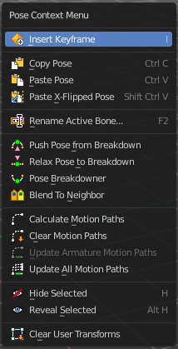
Call this menu with double right click in the 3D viewport. You need to be in Edit mode with a armature object.

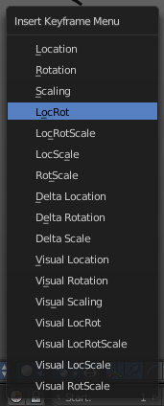
Insert Key frame
Opens a menu where you can insert a key frame with a defined keying set.

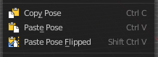
Copy Pose
Copies the current pose. You copy what you have selected.

Paste Pose
Pastes a previous copied pose.

Paste X Flipped Pose
Pastes a previous copied pose, but flipped along X axis.

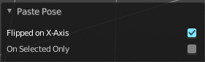
Last Operator Paste Pose

Flipped on X Axis
Paste the pose flipped along X Axis.

On Selected Only
Paste just on the selected bones. Not on the unselected.

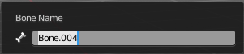
Rename active Bone
Calls a dialog where you can rename the active bone.

Push Pose from Breakdown
Exaggerates the current pose. Pushes the current pose further away from the previous pose.

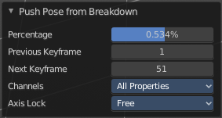
Last Operator Push Pose

Percentage
The percentage of exaggeration.

Previous Key frame
The key frame position before the current frame.

Next Key frame
The key frame position after the current frame.

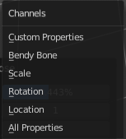
Channels
Limit the push effect to specific channels.

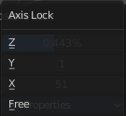
Axis Lock
Limit the push effect to specific axis.

Relax Pose to Breakdown
Relaxes the current pose.

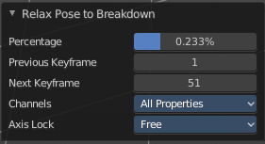
Last Operator Relax Pose to Breakdown

Percentage
The percentage of relaxing.

Previous Key frame
The key frame position before the current frame.

Next Key frame
The key frame position after the current frame.

Channels
Limit the relax effect to specific channels.

Axis Lock
Limit the relax effect to specific axis.

Pose Breakdowner
Creates a suitable breakdowner pose on the current frame.
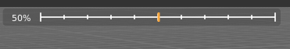
When you perform the tool then you will see a per cent slider in the header where you can read the percentual influence of the blending. Move the mouse to position the blend pose where you need it.

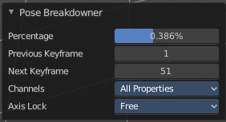
Last Operator Pose Breakdowner

Percentage
The percentage of exaggeration.

Previous Key frame
The key frame position before the current frame.

Next Key frame
The key frame position after the current frame.

Channels
Limit the breakdowner pose to specific channels.

Axis Lock
Limit the breakdowner pose to specific axis.

Blend to Neighbout
Blends the current pose with the neighbouring poses.
When you perform the tool then you will see a per cent slider in the header where you can read the percentual influence of the blending. Move the mouse to position the blend pose where you need it.

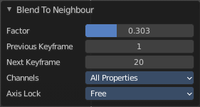
Last Operator Blend to Neighbour

Factor
The blend factor.

Previous Keyframe
The keyframe to calculate from before the current position.

Next Keyframe
The keyframe to calculate from after the current position.

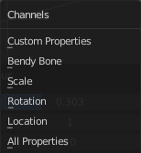
Channels

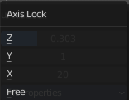
Axis Lock
Lock the transformation along an axis.

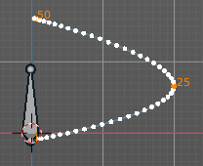
Calculate Motion Paths
Objects can be animated. Let's say you send them from a to b to c. The object will move to b, then to c. Some kind of a path. This path is not visible by default.
With motion paths you can calculate this path, and make it visible.

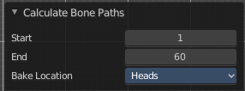
Last Operator Calculate Object Path

Start
Defines the start frame of the calculation.

End
Defines the end frame of the calculation.

Bake Location
Where to draw the curve. At the head or at the tail of the bone(s)

Clear Motion Paths
Clear remove the motion path from the object.

Update Armature Motion Paths
Updates the motion paths for the armature object.

Update All Motion Paths
Updates the motion paths for all objects.

Hide Selected
Hides the selected geometry.

Show Hidden
Makes all hidden geometry visible again.

Clear User Transforms
Resets Pose of selected bones back to key frame state.

